MENU ☰

BASIC NETWORKING

Networking Basics
- Goals:
  - In the Azure Cloud (Or any cloud), we are responsible for virtual network and Physical network with in Azure Hardware is managed by Microsoft
  - Create Virtual Network for your architecture so, creating networks for applications, exposing necessary servers to internet. Deny all the other access
  - Understand and implementing Virtual Private Networks
  - Enabling DNS (Public and Private)

IP Address
- Unique address given to a system in a network to communicate.
- There are currently two main versions of IP Address
  - IPv4
  - IPv6
- IPv4:
  - IPv4 is made up of 32 bits, Because of this , there are 2^32 (4294967296) possible IP Addresses
  - Each IPv4 address is broken down into four sections 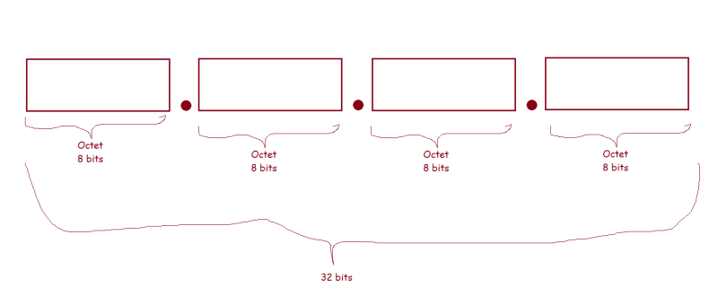 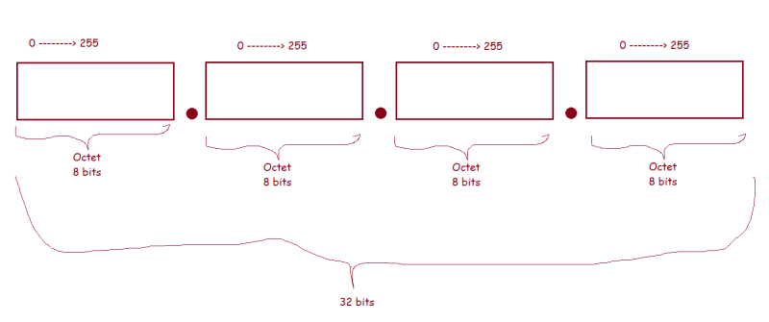
  - Lets look at decimal representation and binary representation of some ip addresses
- 192.168.0.10 => decimal representation
- 11000000.10101000.00000000.00001010 => binary represenation

- 20.25.34.7 => decimal
- 00010100.00011001.00100010.00000111 => binary representation

- 10.0.0.2 => decimal
- 00001010.00000000.00000000.00000010
  - Execute ipconfig on your laptop
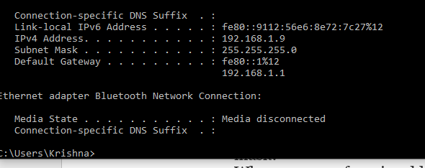
  - Observations about IP Addresses
    - What is purpose of Default Gateway and subnet mask?
    - Why are most of our ip addresses starting with 192.168.x.x or 10.x.x.x in our office network
  - IP Address holds
    - network id
    - host id
  - But to determine the network id and host id we need a subnet mask
- 192.168.0.198
- 255.255.255.0

- network id
- 192.168.0

- host id
- 198

- 192.168.0.11
- 255.255.0.0

- network
- 192.168

- host id
- 0.11

- 10.0.0.7
- 255.255.255.0

- network id (3 octets)
- 10.0.0

- host id (1 octet) => 2^8 ~= 256
- 7

- 172.16.0.8
- 255.255.0.0

- network id
- 172.16

- host id (2 octets => 2^16 ~= 65536)
- 0.8

- Possible subnet mask’s as per what we understood
SM => 255.255.255.0 => Host (1 Octet) => 2^8 ~= 256
=> 255.255.0.0 => Host (2 octets) => 2^16 ~= 65536
=> 255.0.0.0 => Host (3 Octets) => 2^24 ~= 16777216
- Lets assume i need a network
  - with 200 devices => SM => 255.255.255.0
  - with 500 devices => SM => 255.255.0.0
- Now lets look at networks. A network can be regarded as one of the following types
  - Classful networks
  - Classless networks
- Classful Networks:
  - In terms of classfull networks we have five classes
    - A
    - B
    - C
    - D
    - E
 | Class A | Class B | Class C
Address Range | 0.0.0.0-127.255.255.255 | 128.0.0.0-192.255.255.255 | 192.0.0.0 – 223.255.255.255
Defult Subnet Mask | 255.0.0.0 | 255.255.0.0 | 255.255.255.0
Maximum Number of Hosts | 16777214 | 65534 | 254
private address range | 10.0.0.0 – 10.255.255.255 | 172.16.0.0 – 172.31.255.255 | 192.168.0.0 – 192.168.255.255
- Class D compromises of range of IP addresses that are set aside for multicast transmission purpose 224.0.0.0 - 239.255.255.255
- Class E is set aside for expermimental purposes 240.0.0.0 - 255.255.255.255
- Classles Inter Domain Routing (CIDR)
  - This was introduced to replace classfull addresses. It uses variable length subnet masks
  - This has introduced a CIDR notation
- Subnet mask in binary
SM in binary:
255.255.255.0
11111111.11111111.11111111.00000000 => 8 zeros => 2^8 -2 => 254

11111111.11111111.11111110.00000000 => 9 zeros => 2^ 9 -2 => 512 - 2 => 510

100 devices => 2^n ~= 100 => n = 7 i.e 7 zeros

11111111.11111111.11111111.10000000 => 7 zeros => 2^7-2 => 126

1500 devices

11111111.11111111.11111000.00000000 => 2^11 = 2046
- Possible SM’s in a octect
11111111 => 255
11111110 => 254
11111100 => 252
11111000 => 248
11110000 => 240
11100000 => 224
11000000 => 192
10000000 => 128
- The CIDR notation denotes subnet mask by /X
192.168.0.0/24
SM => 255.255.255.0
ip range 192.168.0.0 - 192.168.0.255

192.168.0.0/16
SM => 255.255.0.0
ip range => 192.168.0.0 - 192.168.255.255

192.168.0.0/23
SM => 255.255.254.0

192.168.0.0/23

11111111.11111111.11111110.00000000

11000000.10101000.0000000 0.00000000 => 192.168.0.0
11000000.10101000.0000000 1.11111111 => 192.168.1.255

10.10.128.0/22 => 32 -22 => 10 => 2^10 -2 => 1022

SM => 11111111.11111111.11111100.00000000

IP => 00001010.00001010.100000 00.00000000 => 10.10.128.0

00001010.00001010.100000 11.11111111 => 10.10.131.255

- Exercise: Try to find the ip ranges for the following CIDR notations
172.16.0.0/12
192.168.0.0/16
10.0.0.0/8

10.100.192.0/20
10.10.0.0/21

- In any network, We cannot use 2 IP addresses
  - All 0 will be Network Id
  - All 1 (255) will be broadcast id
- In the case of Azure we cannot 5 IP Addresses
  - All 0 will be Network Id (x.x.x.0)
  - ALL 1 will be broadcast id (x.x.x.255)
  - x.x.x.1 Reserved by Azure for the default gateway
  - x.x.x.2 and x.x.x.3 Reserved by Azure to Map the Azure DNS IPs to VNET Space
- In Azure the Smallest subnet possible is /29

